Login page without any input
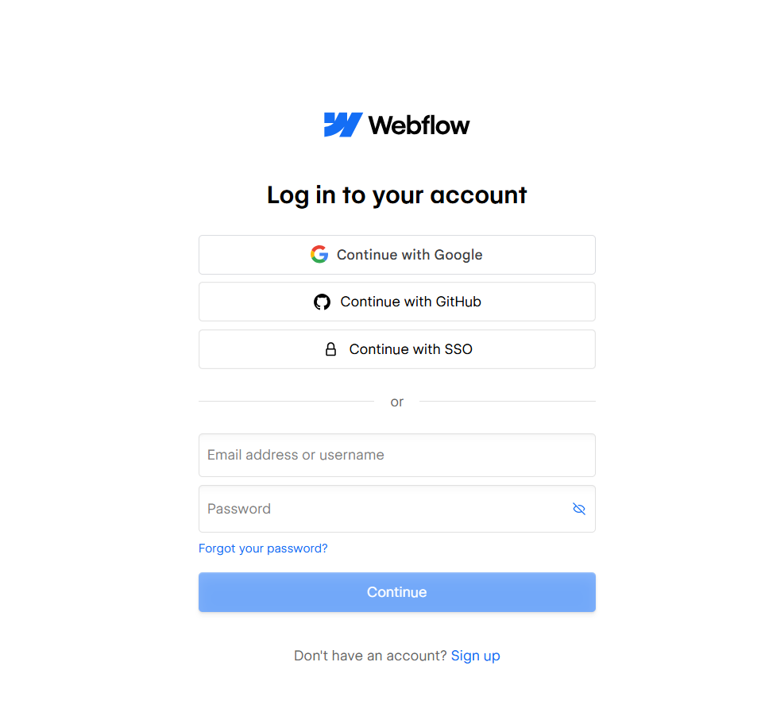

Invalid email/password combination wala yellow error message.
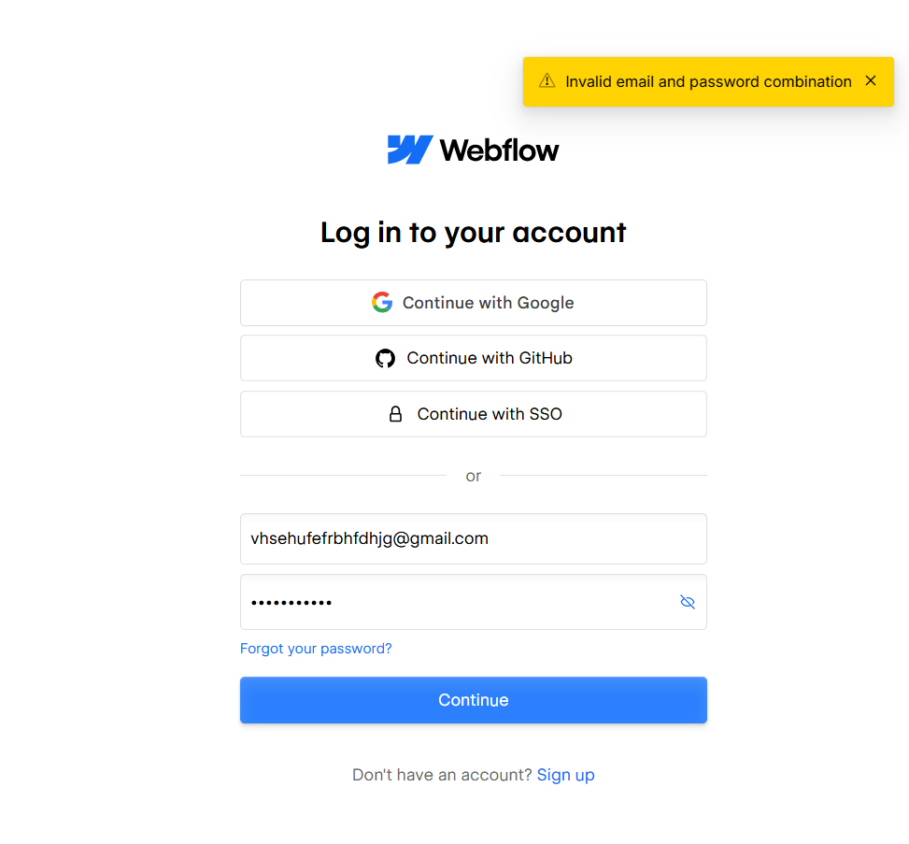
Invalid email format + “Invalid email address” error.
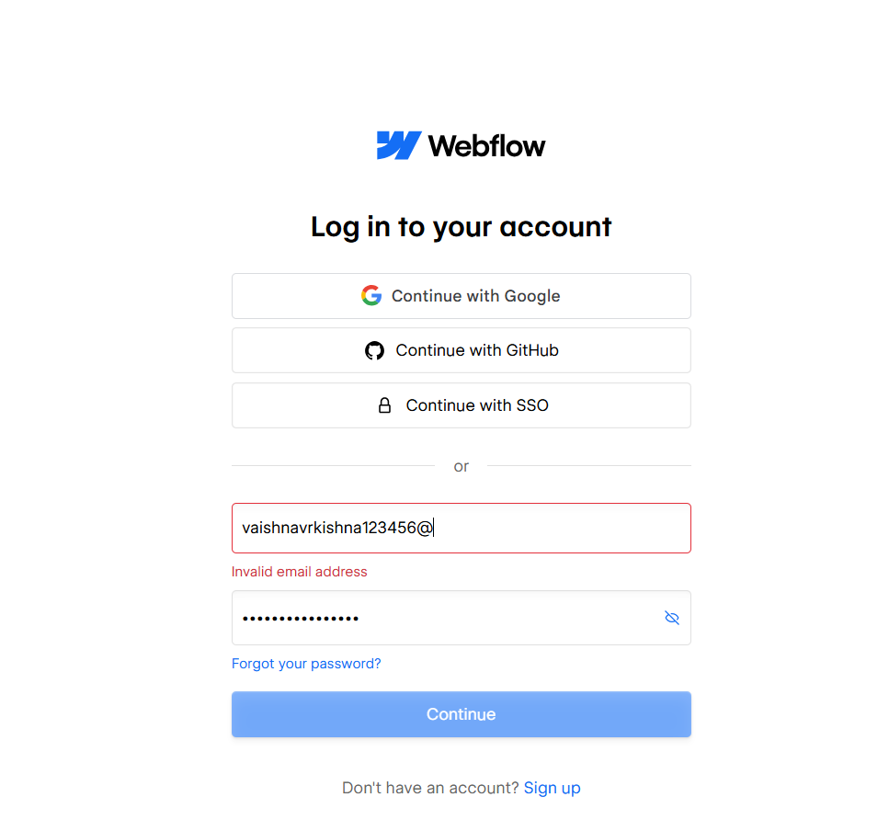
Blank email/password fields. Blank email/password fields. 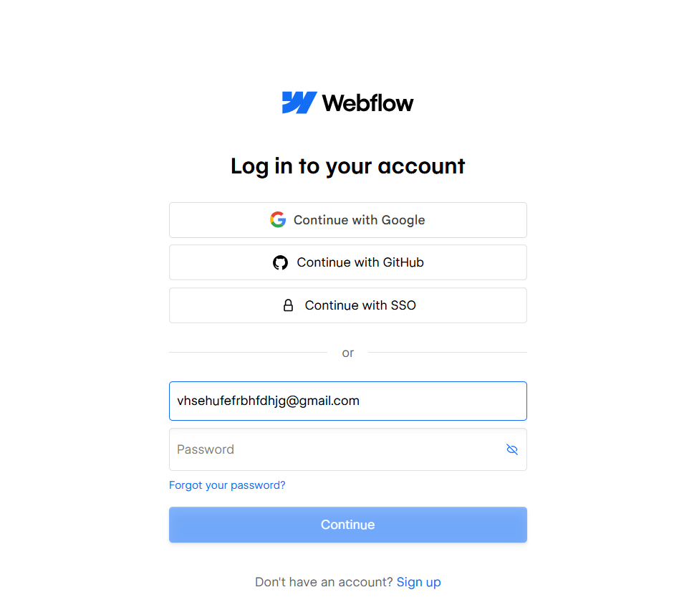

Password field filled/masked and eye icon visible. 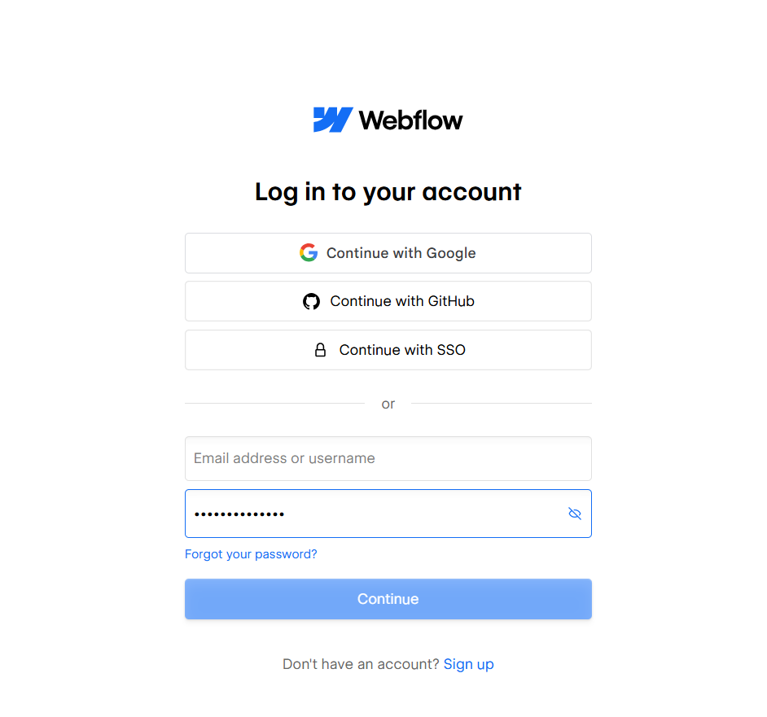
Successful login ke baad Webflow dashboard 